**1. Appservice**

<https://github.com/MicrosoftLearning/AZ-204-DevelopingSolutionsforMicrosoftAzure/blob/master/Instructions/Labs/AZ-204_lab_01.md>

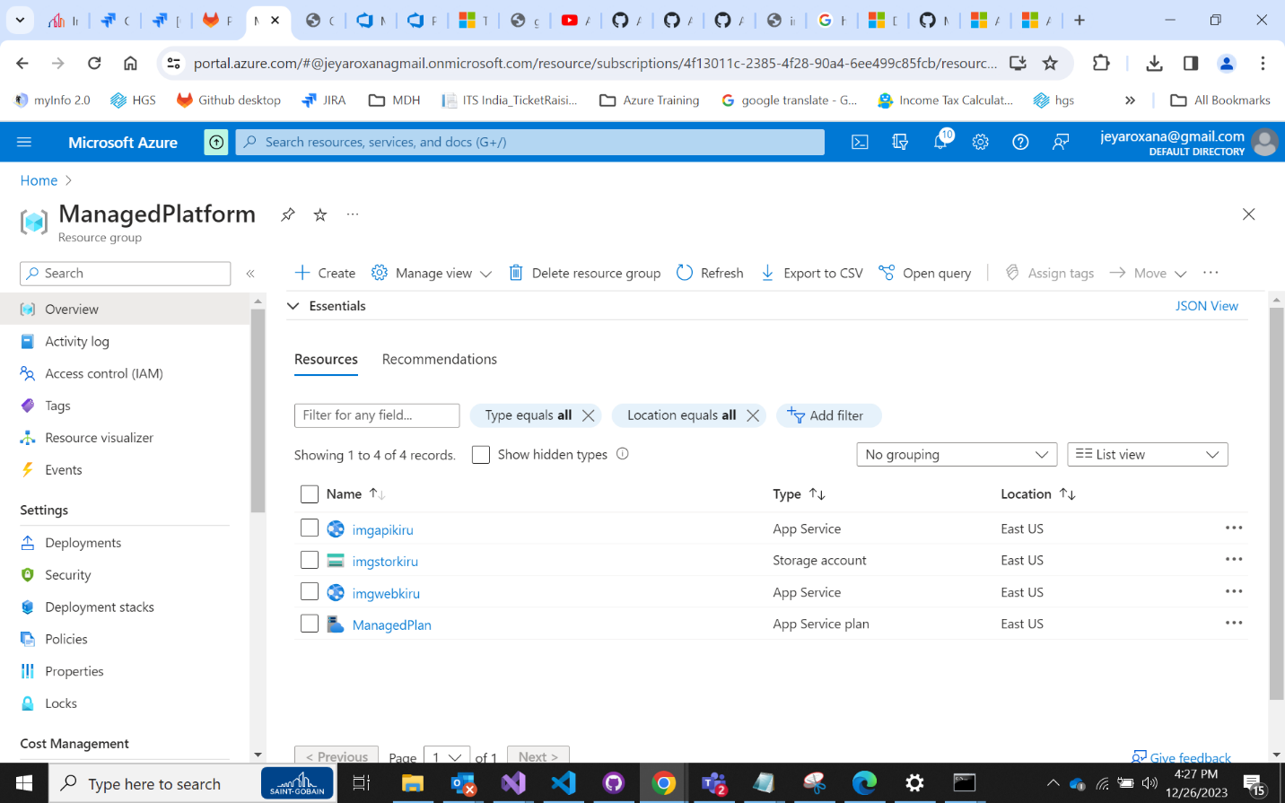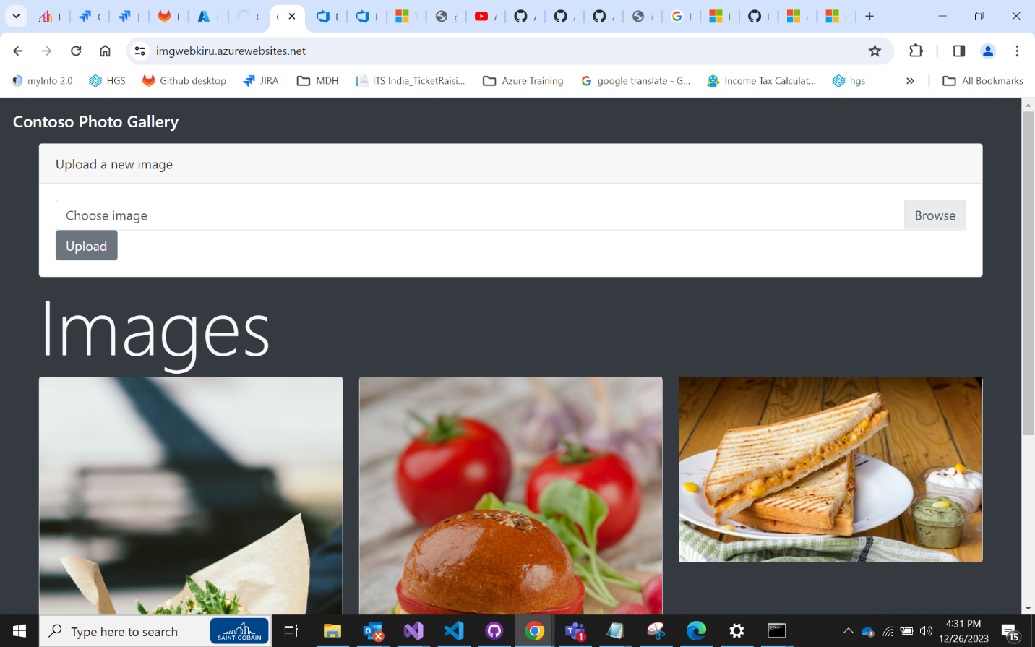

**2. Azure functions**

<https://github.com/MicrosoftLearning/AZ-204-DevelopingSolutionsforMicrosoftAzure/blob/master/Instructions/Labs/AZ-204_lab_02.md>

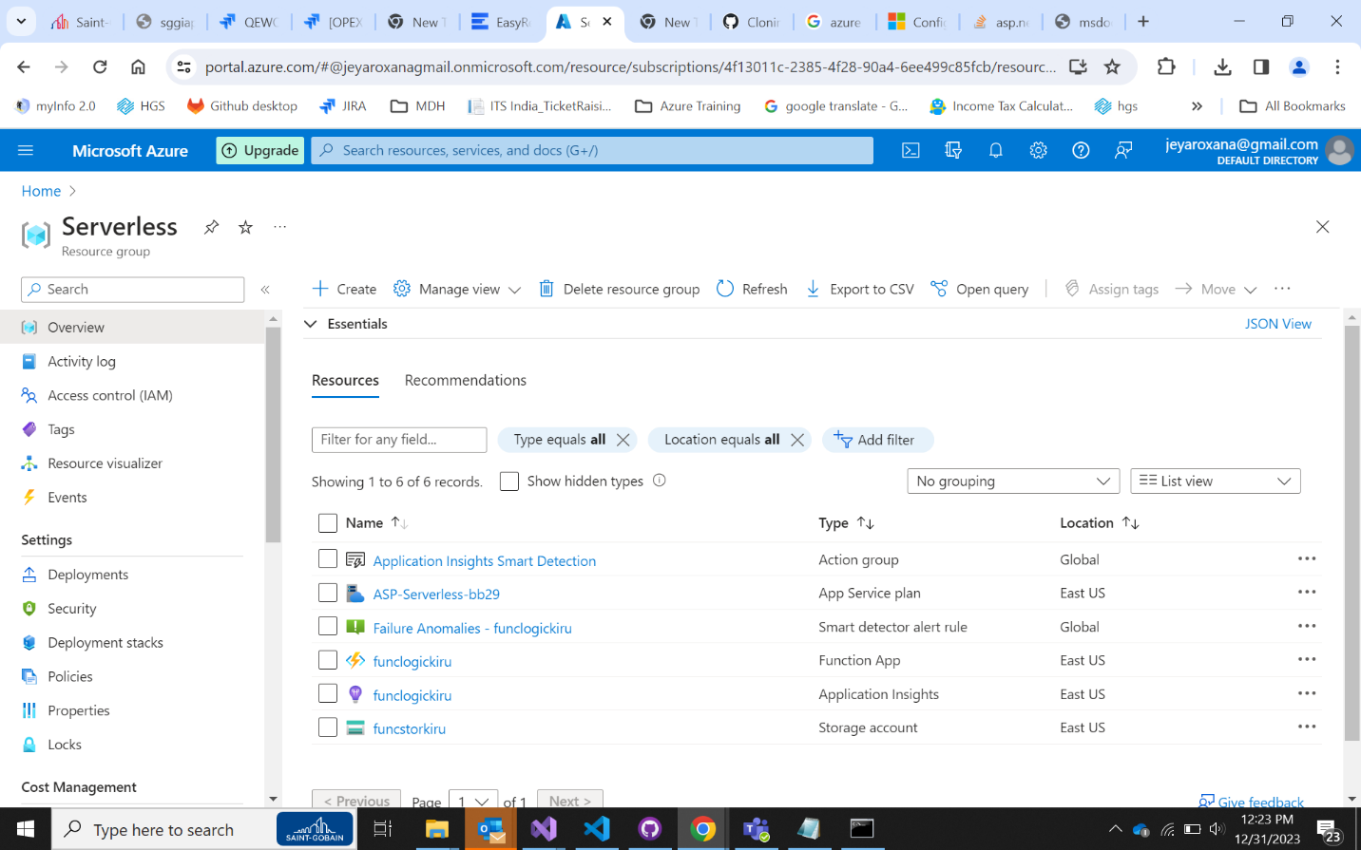

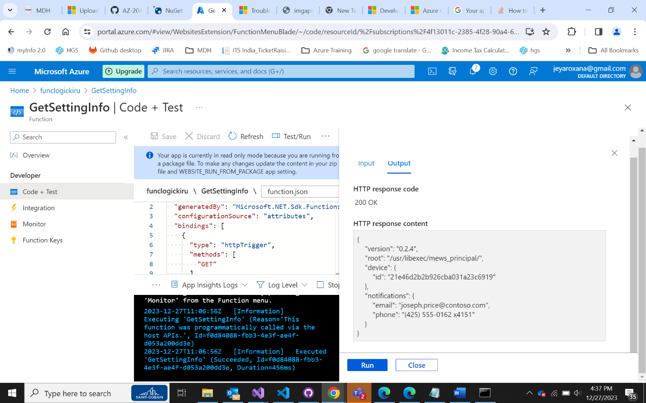

**3. Storage Accounts**

<https://learn.microsoft.com/en-us/azure/storage/blobs/blob-upload-function-trigger?tabs=azure-portal>

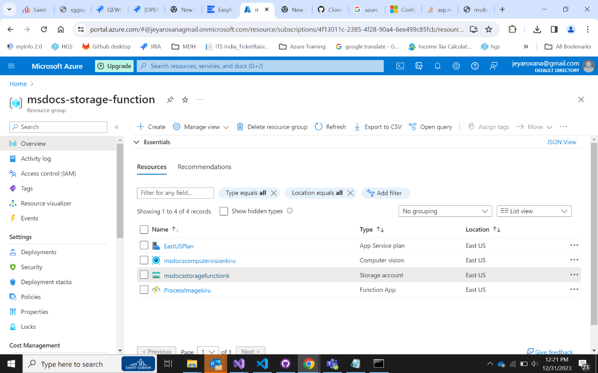

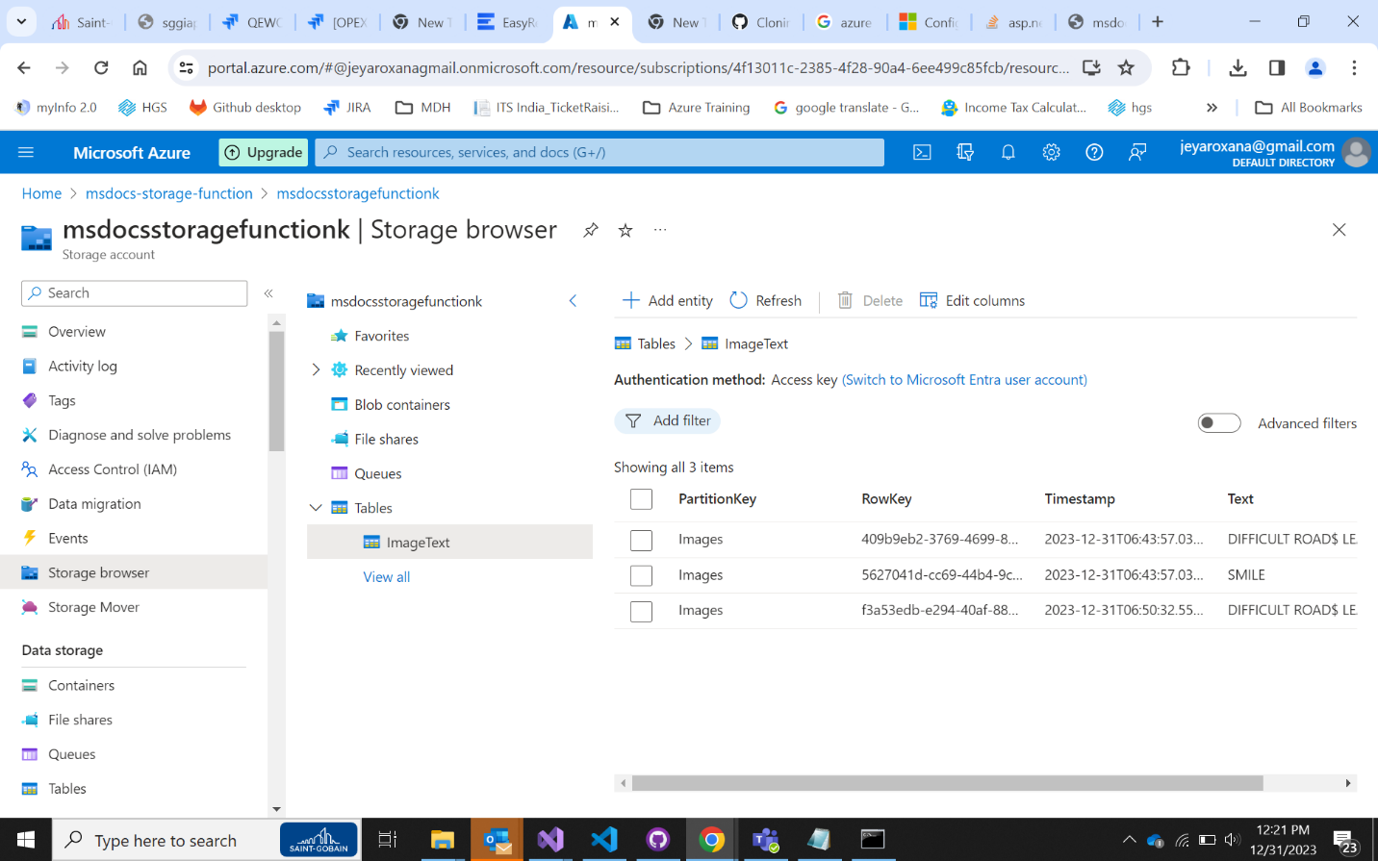

**4. SQL DB**

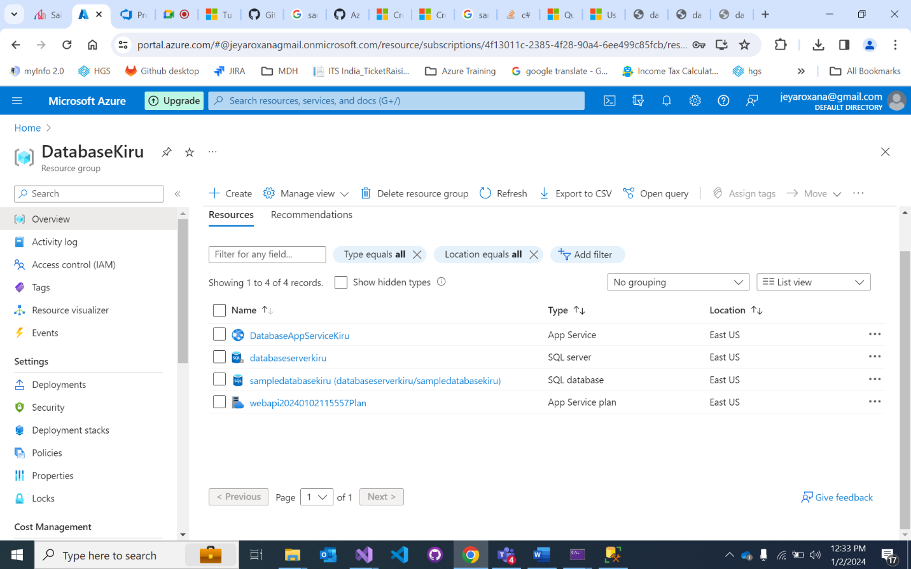

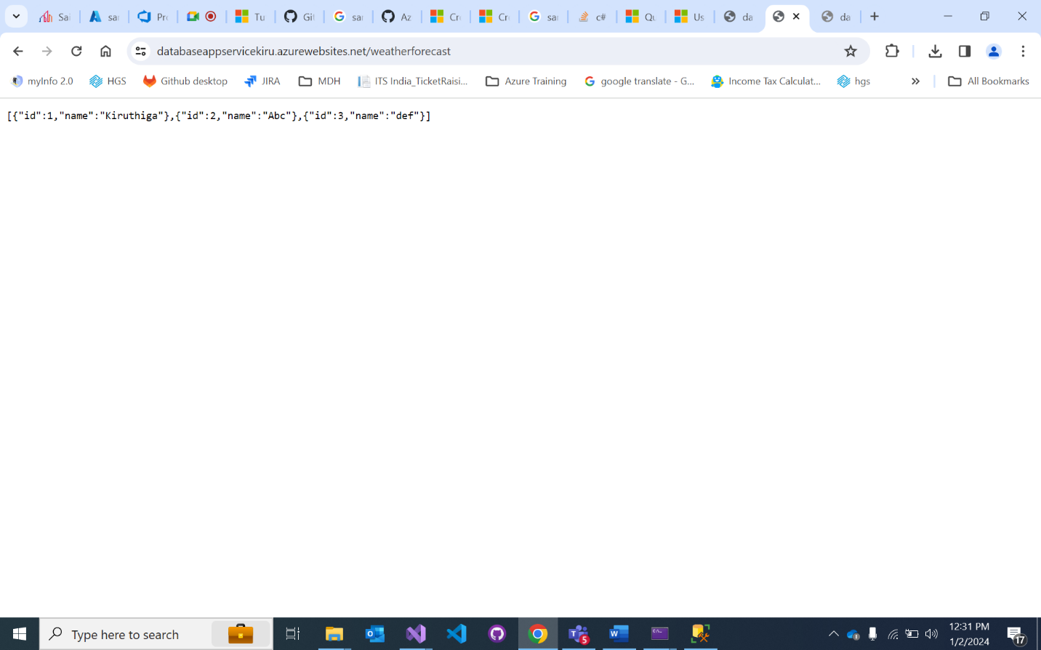

**5. Redis cache**

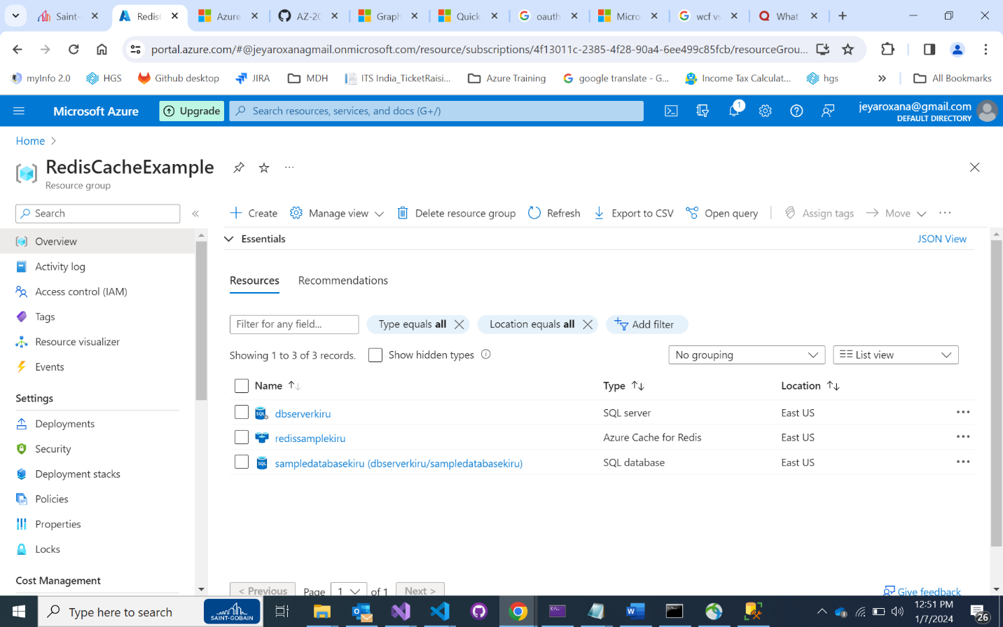

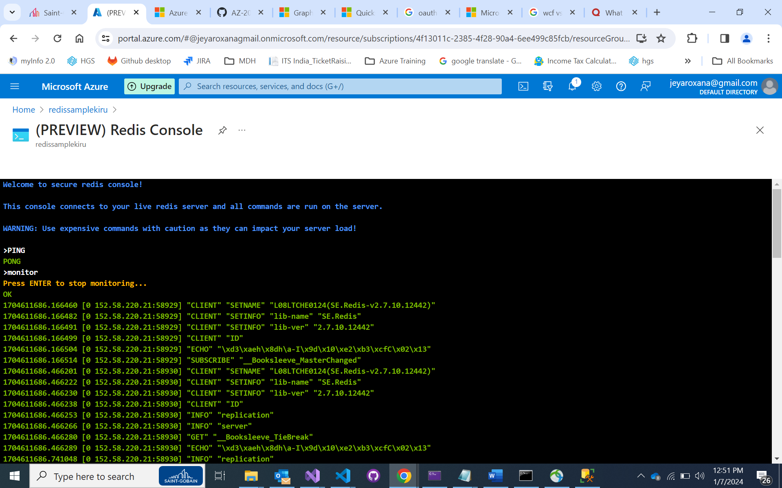

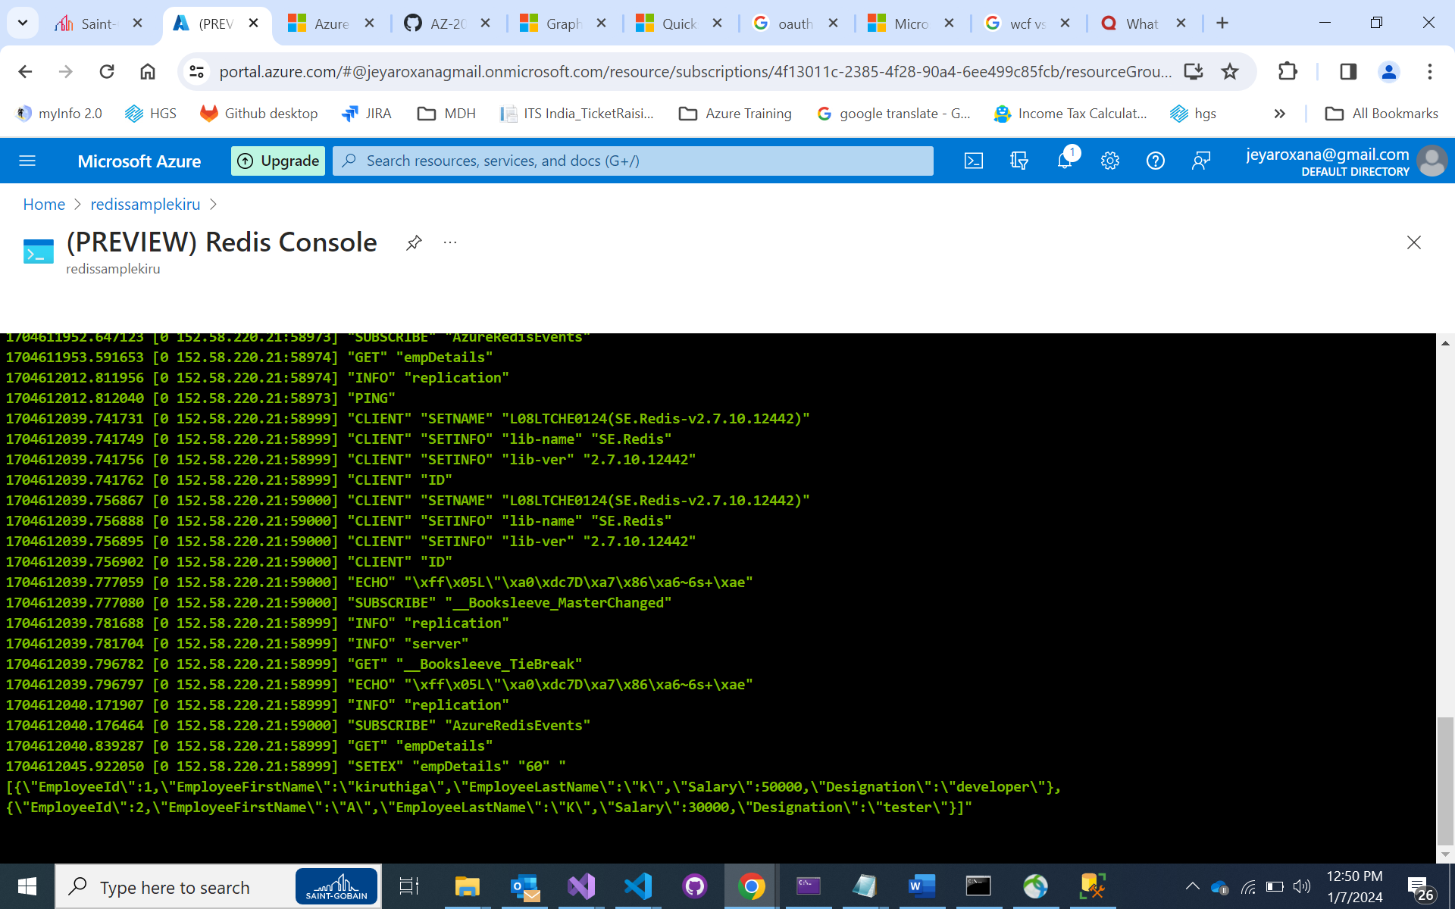

**6. MSAL- Identity (AZ 204 Lab 06)**

<https://github.com/MicrosoftLearning/AZ-204-DevelopingSolutionsforMicrosoftAzure/blob/master/Instructions/Labs/AZ-204_lab_06.md>

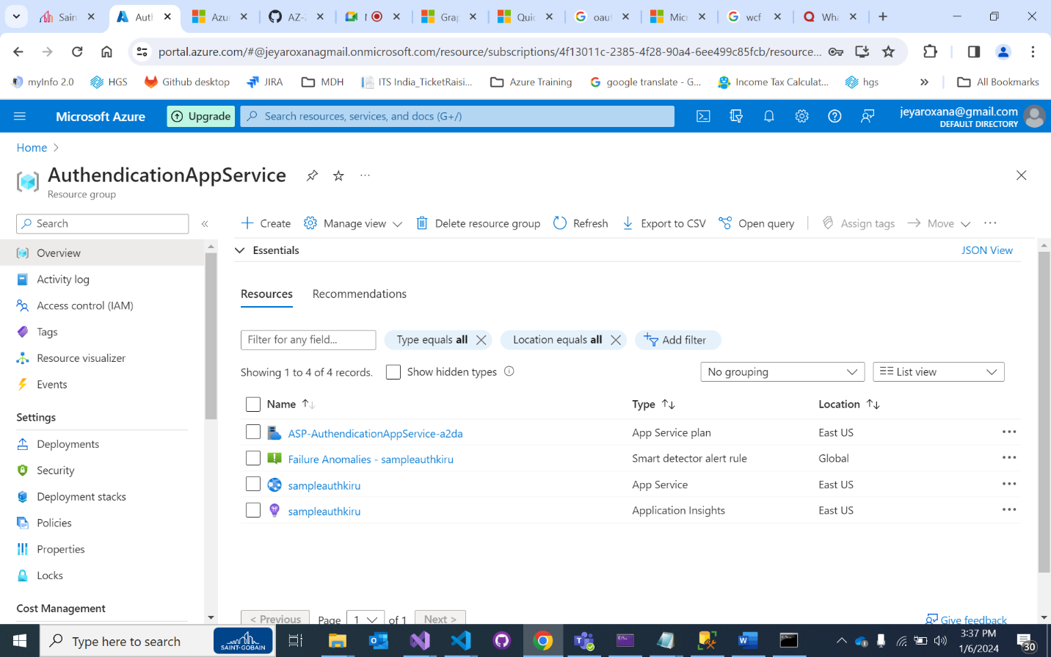

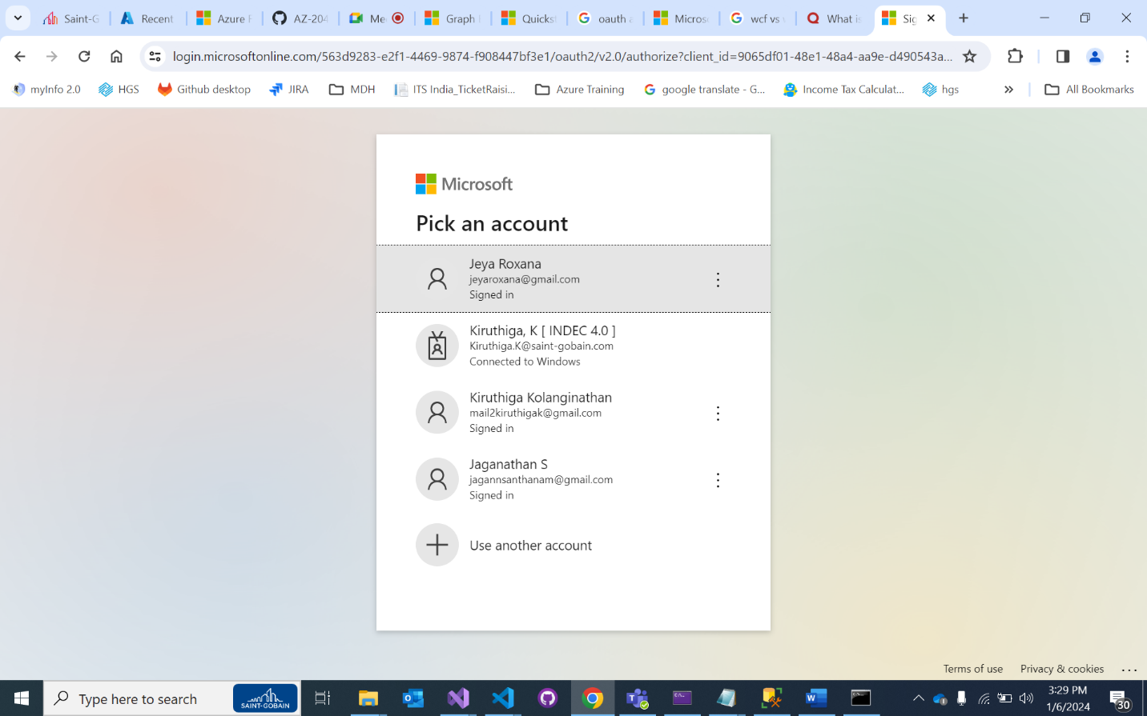

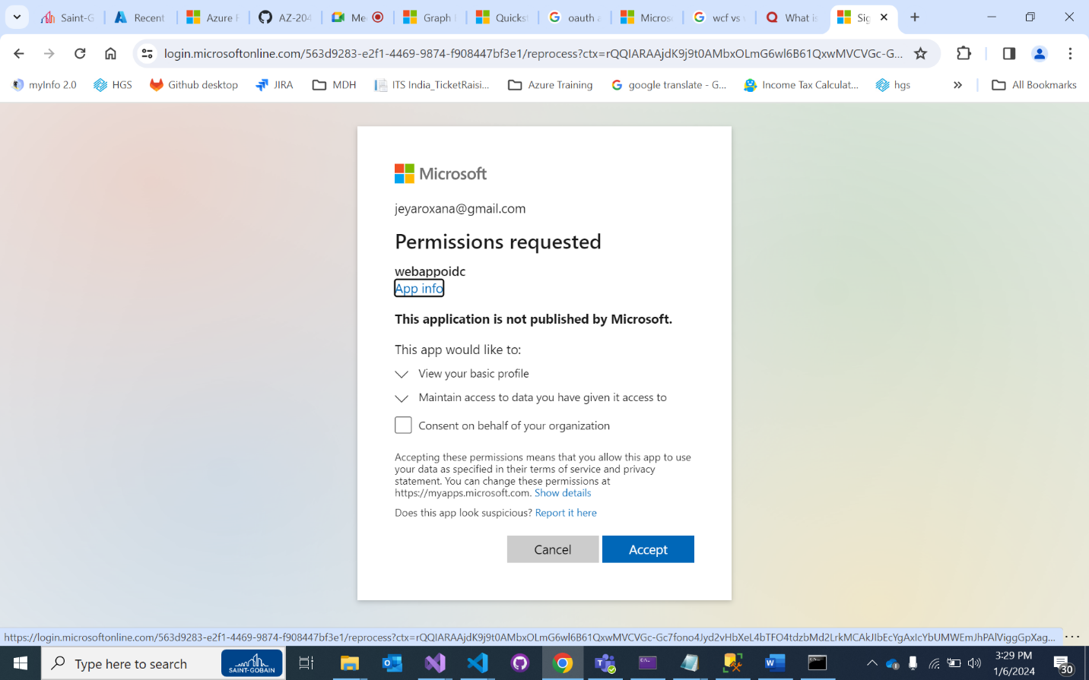

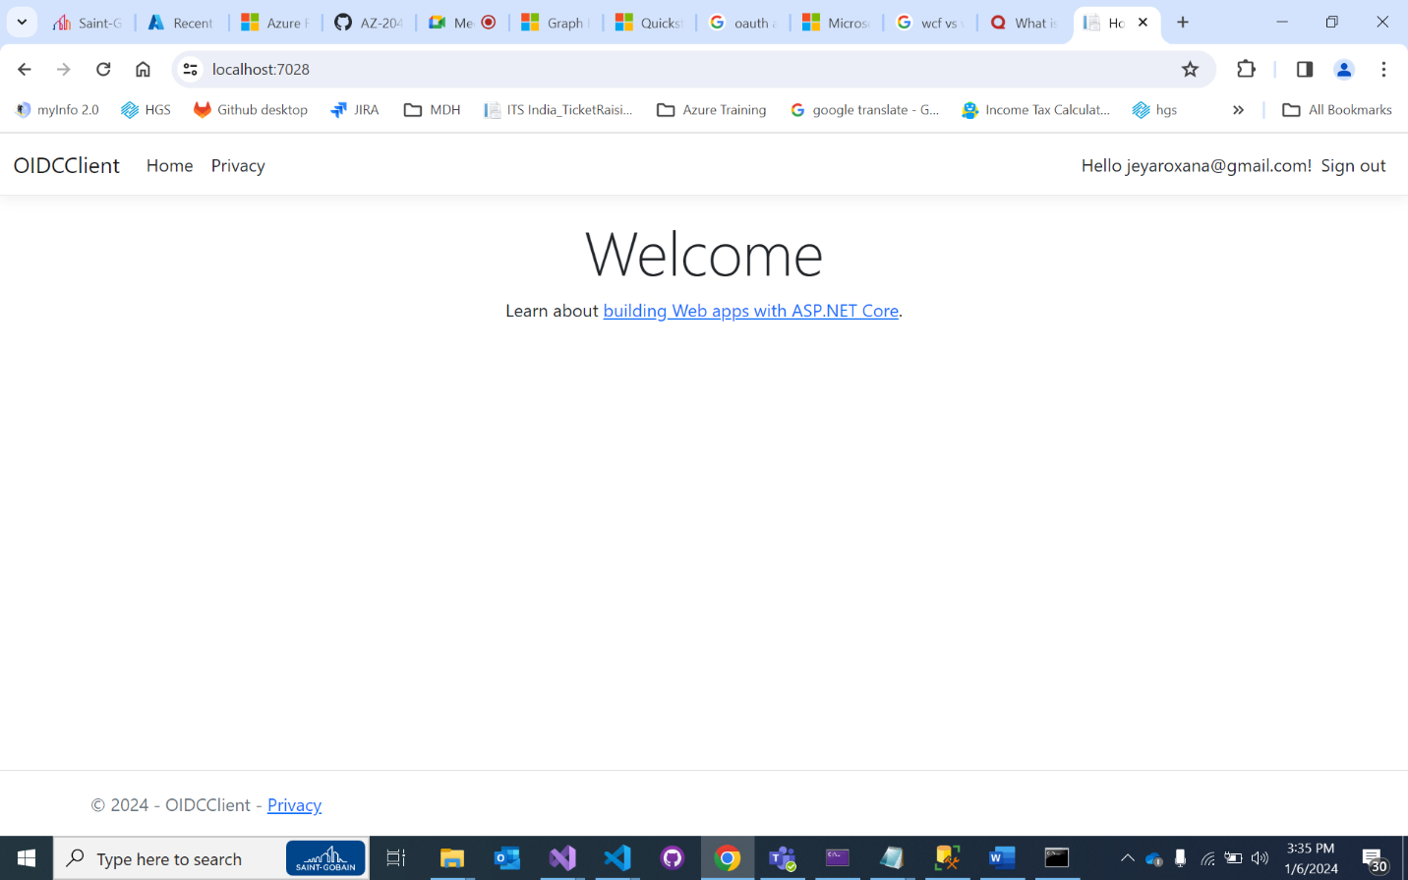

7. <https://github.com/MicrosoftLearning/AZ-204-DevelopingSolutionsforMicrosoftAzure/blob/master/Instructions/Labs/AZ-204_lab_07.md>

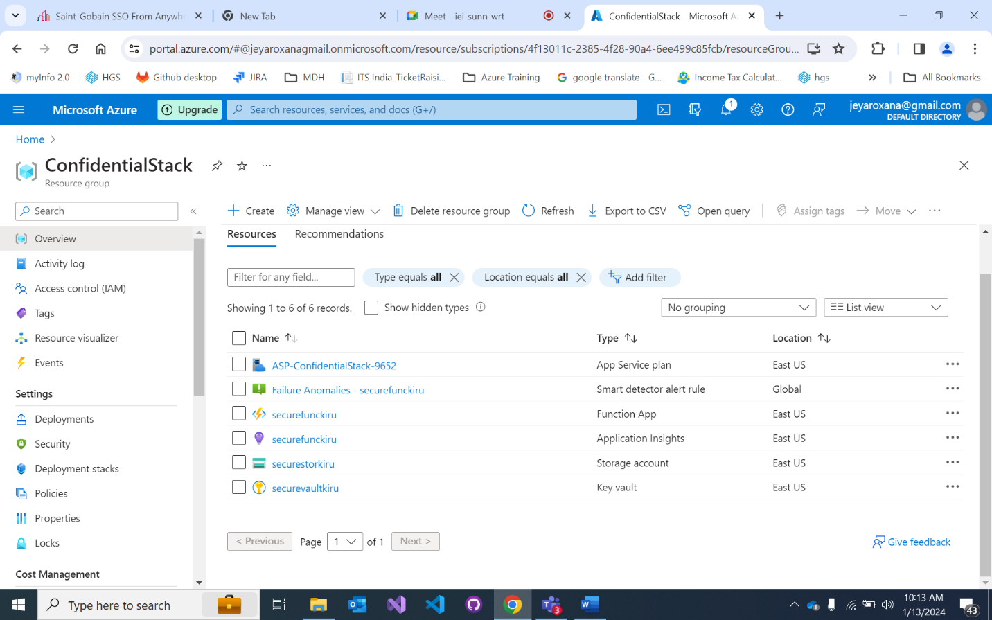

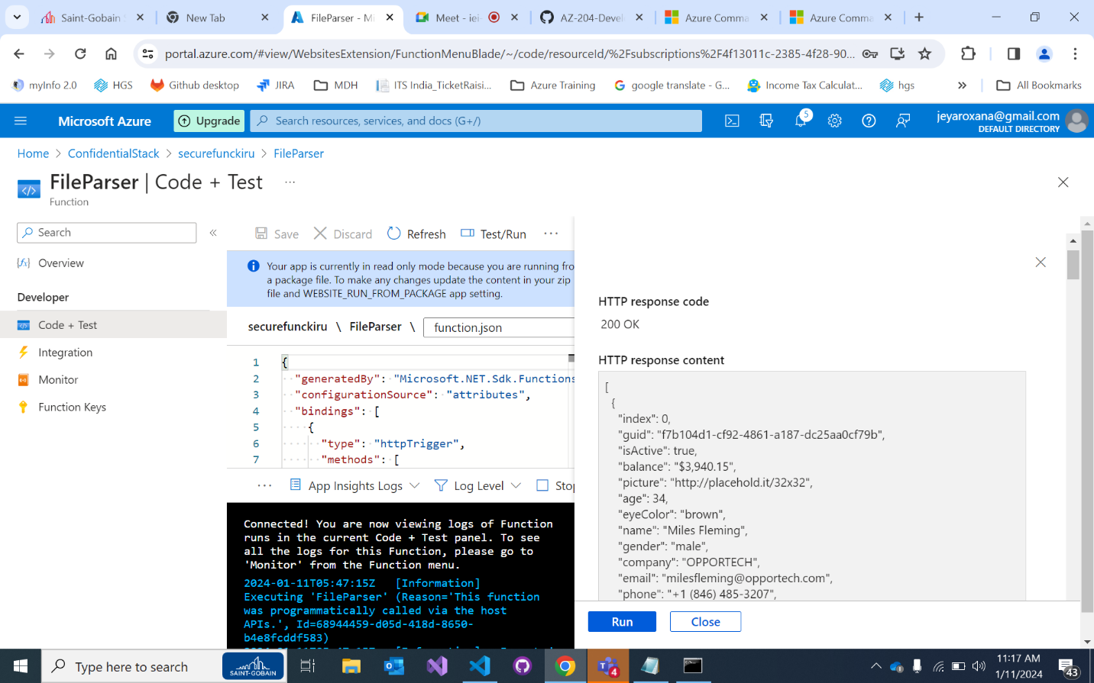

8. <https://github.com/MicrosoftLearning/AZ-204-DevelopingSolutionsforMicrosoftAzure/blob/master/Instructions/Labs/AZ-204_lab_08.md>

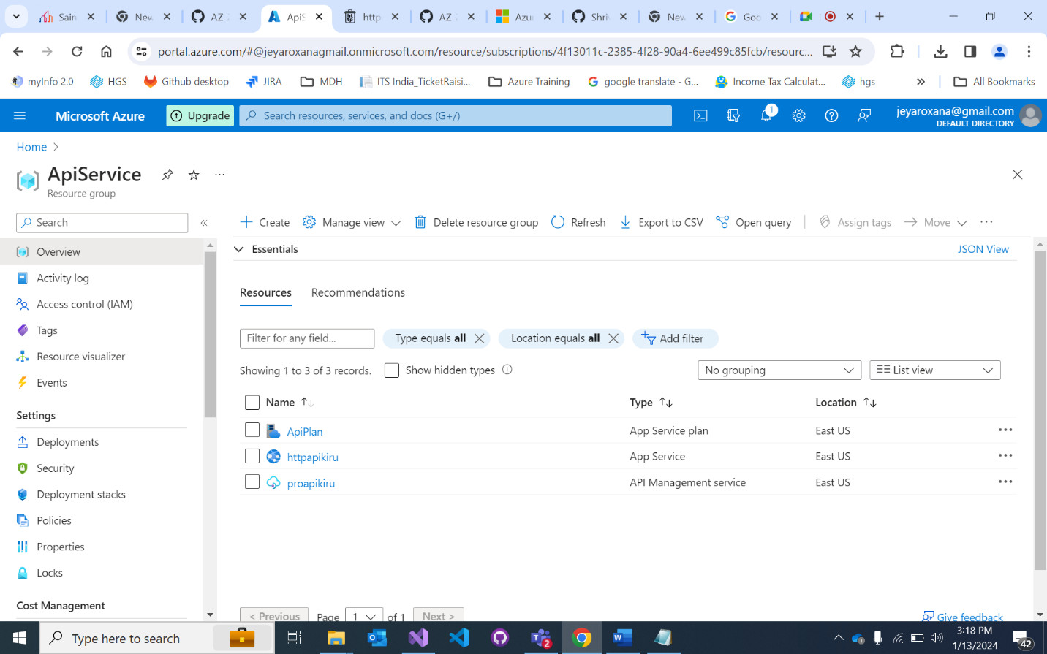

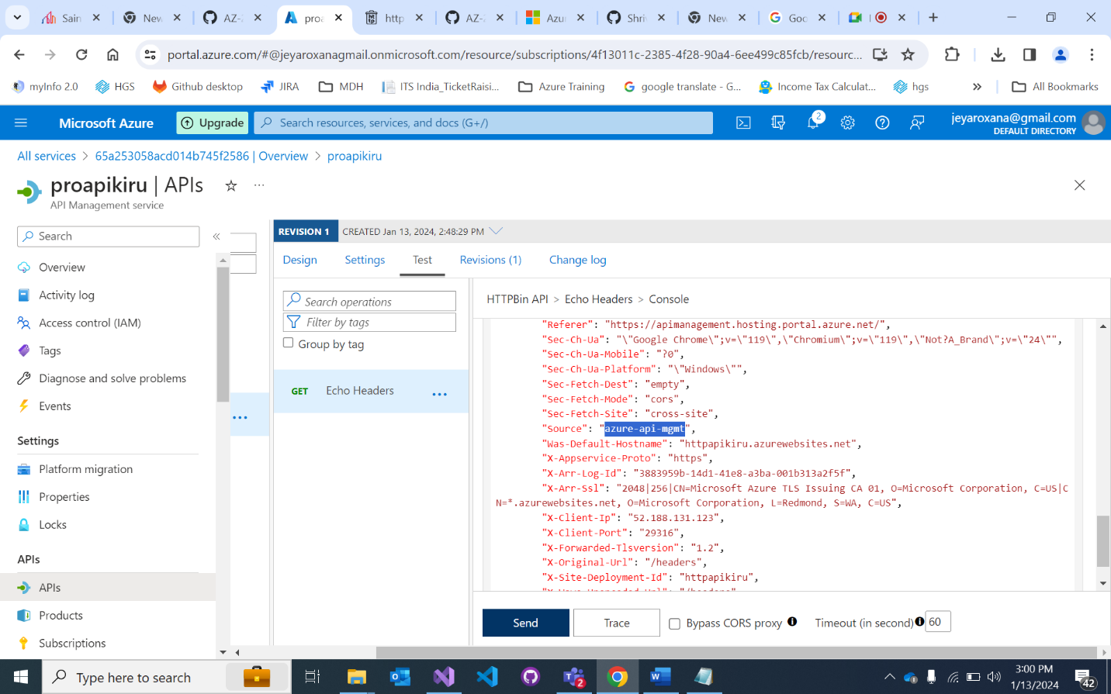

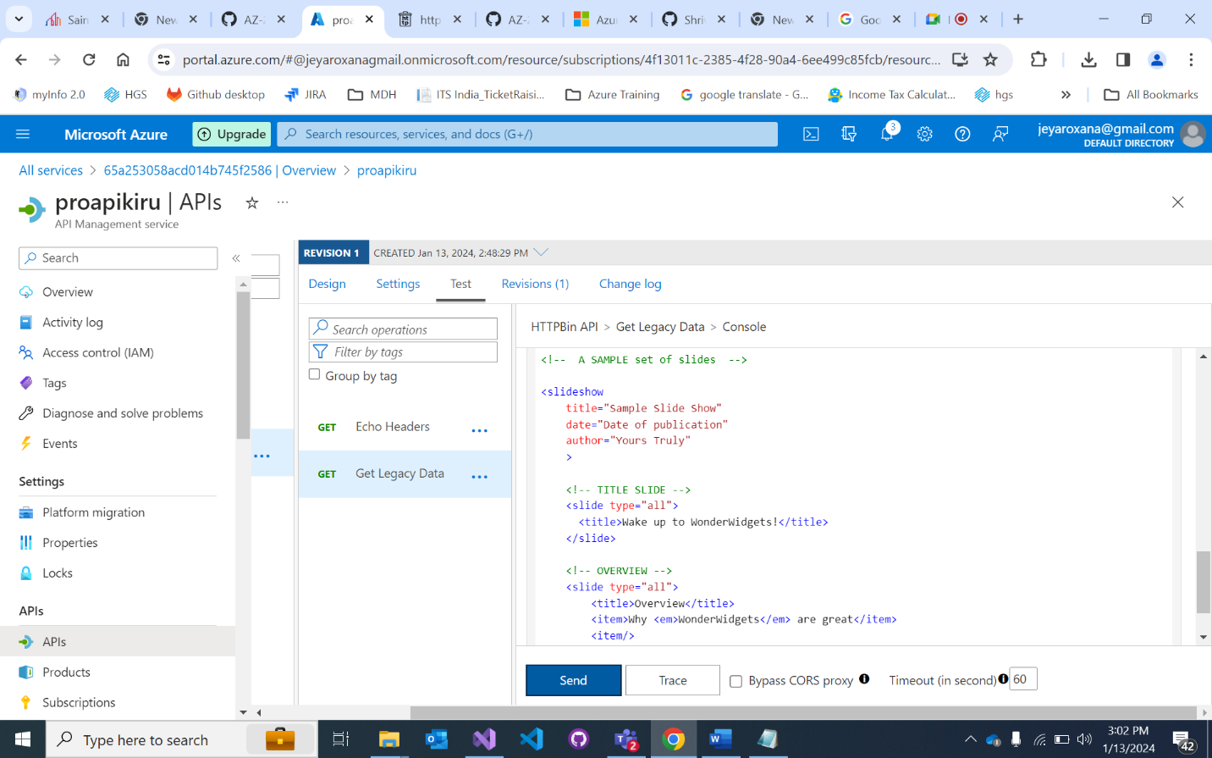

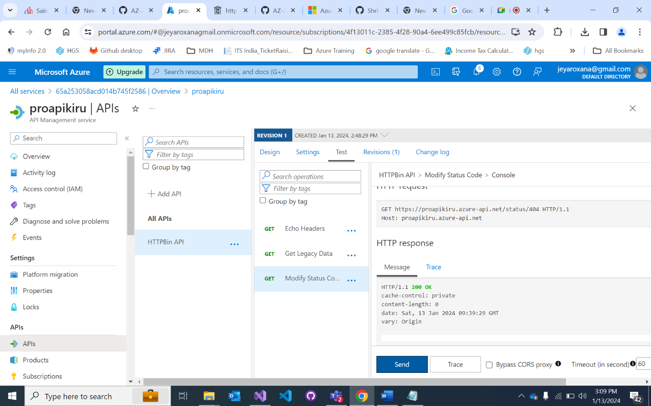

9. <https://github.com/MicrosoftLearning/AZ-204-DevelopingSolutionsforMicrosoftAzure/blob/master/Instructions/Labs/AZ-204_lab_10.md>

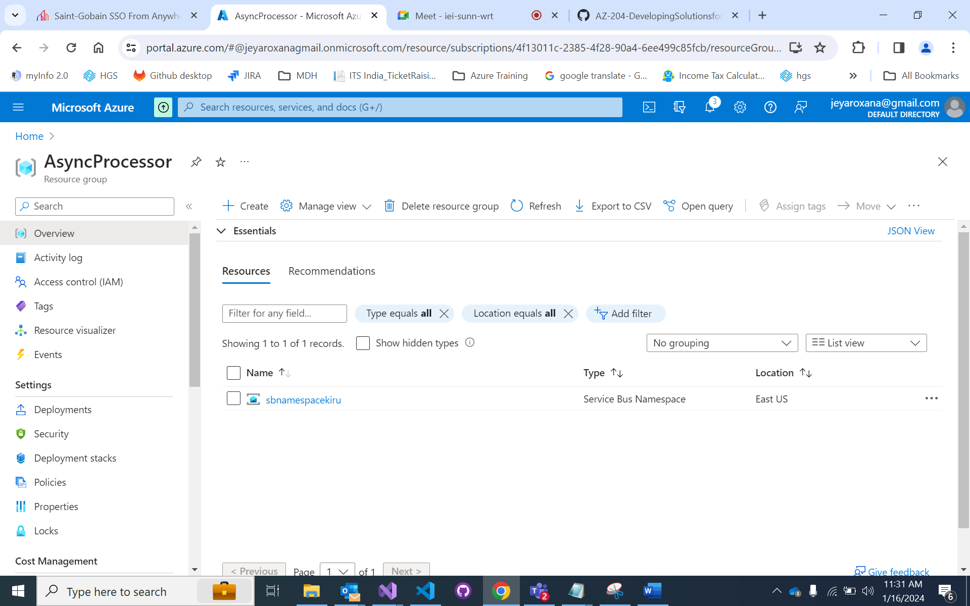

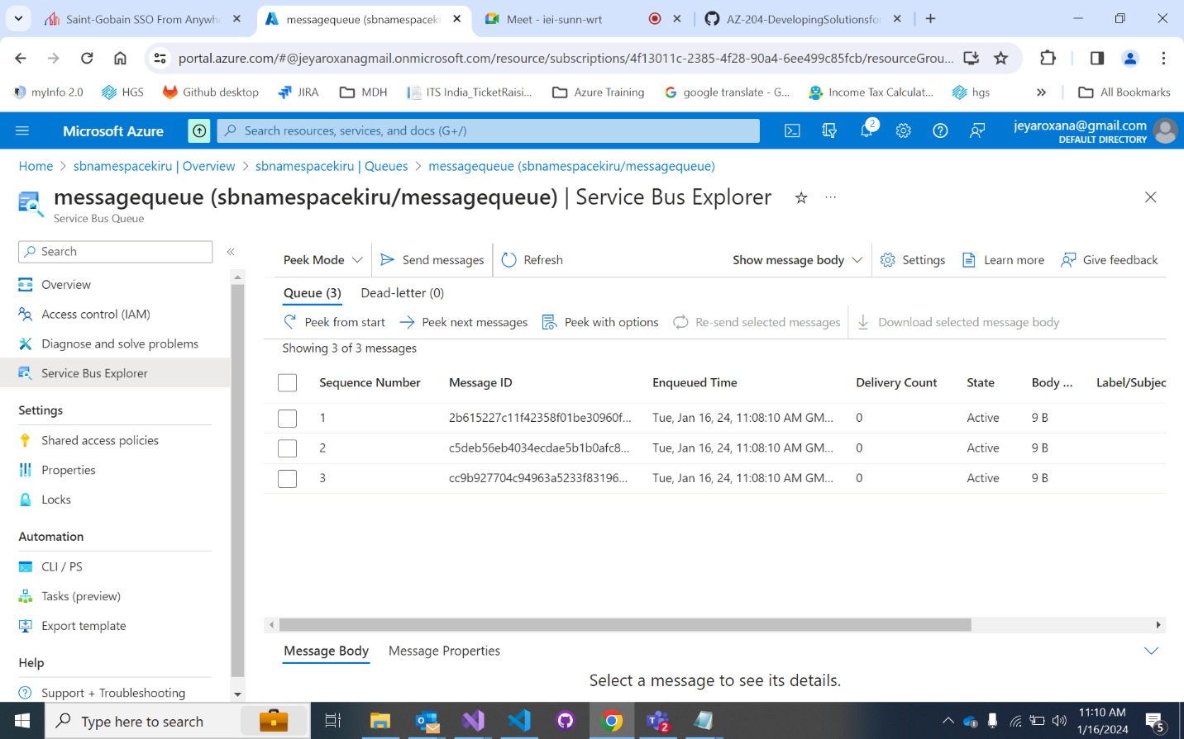

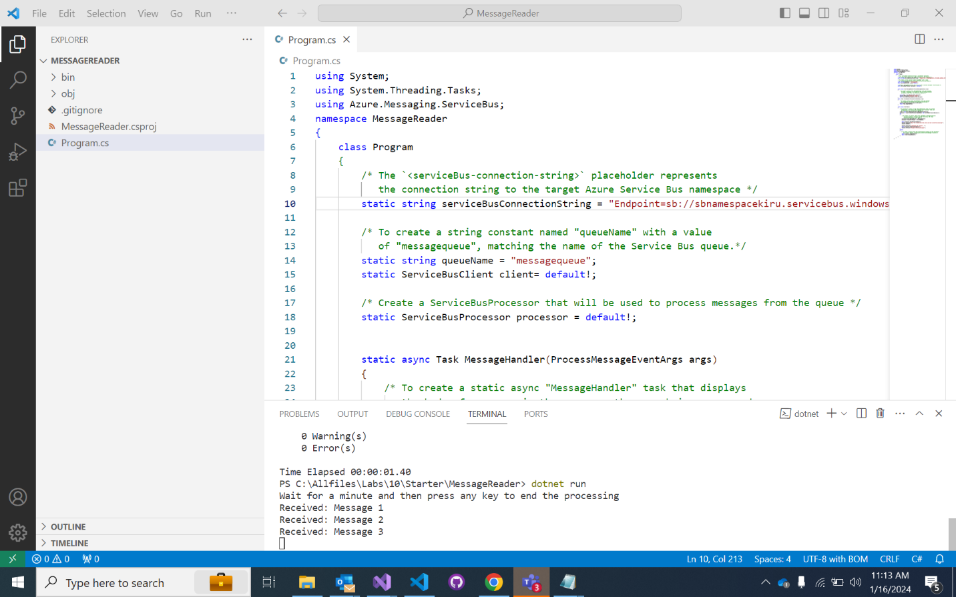

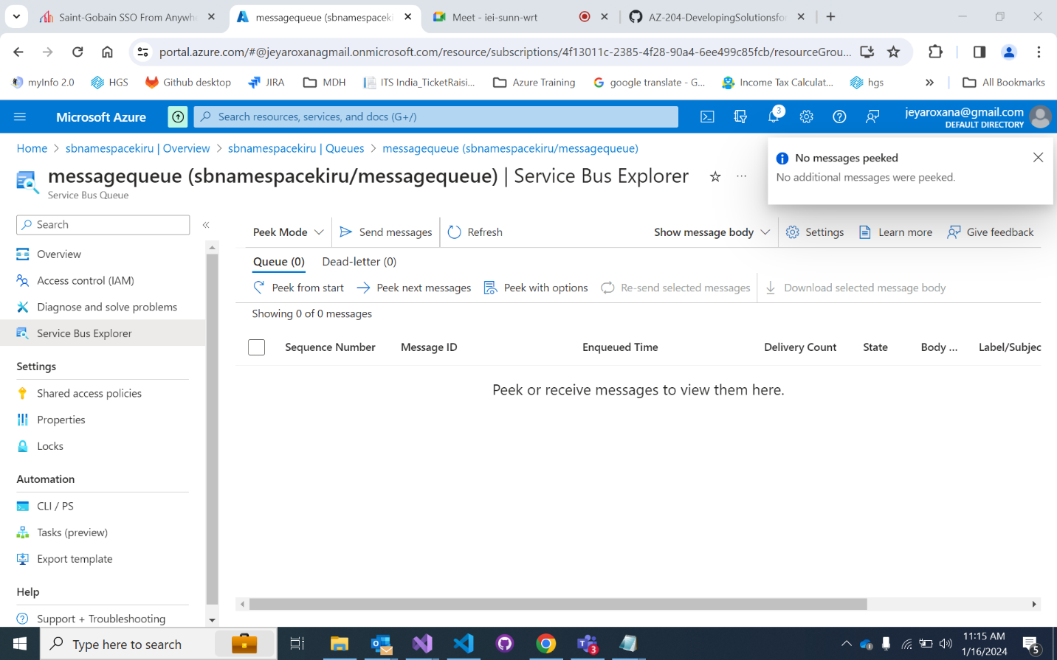

10. <https://github.com/MicrosoftLearning/AZ-204-DevelopingSolutionsforMicrosoftAzure/blob/master/Instructions/Labs/AZ-204_lab_12.md>

